Minutes for the BIM Acceleration Committee
Wednesday, 11 March 2020, 10:00am – 1:00pm
Agenda Item # | Agenda Item
1 | Membership
2 | Strategy Planning FY20
3 | BIMinNZ Website Analytics
4 | Network Groups

- Membership
The committee extended their thanks to Emma Moss who stepped in as the temporary Network Coordinator and also welcomed their newest member Renee Clark who taken over this role permanently.
Andy Lyon from Kiwi Rail was formally invited to the committee and is due to start 15 April 2020.
- Strategy Planning FY20
The original strategic objective was to generate demand and create ability to supply. Over the past 6 years the Committee believe that the industry and supply chain has matured and the new strategic focus for FY20-FY23 will look into knowledge dissemination, industry engagement and the right information in the right format at the right time.
The strategy session was started with a knowledge matrix (control document – see appendix 1) that tested the wants and needs desired by the consumers. The key themes that came out of this were; 1. Knowledge of what BIM is, 2. Knowledge of what BIM does, 3. Knowledge of how to use BIM and 4. Knowledge of what the advantages of using BIM might be. The Committee then identified themes and work strands that were tied to the overall strategic objectives.
The next step is to link the existing projects and proposed list of new projects informed by the knowledge matrix and prioritise the workload for BAC members.
- BIMinNZ Website Analytics – January / February 2020
Visitor numbers for January remained consistent with December sitting at 650 as opposed to 680 the previous month. However, there was a significant increase in visitor numbers in February sitting at 1,020 which is consistent with previous years for February. Across the board there was an increase in visitors to traffic channels, incoming links, outgoing sources, case studies and news articles. It was noted that the BIM handbook numbers were up significantly in February sitting at 210 as opposed to December at 95. The BIMinNZ website was one of the focuses at the strategy planning session in March. The committee will look at ways in which to get knowledge out to the industries that is current and up to date.
- Network Group Attendee Numbers
Christchurch, Mar 3 – 50 participants
Wellington, Mar 4 – 75 participants
Auckland, Mar 5 – No event took place in March for the Auckland network and has been pushed out, date TBC.

Historically, Wellington has struggled for numbers for their events, however, March saw an increase in attendees. The committee believe the increase was enhanced by the speakers from both Wellington City Council and NZTA. The committee will explore ways in which they can supp support the networks, whether it is through administration helps, advertising or marketing to enhance the success of the network groups.

Forward meeting dates:
Next meeting: Wednesday, 15 April 2020, 10am – 12pm

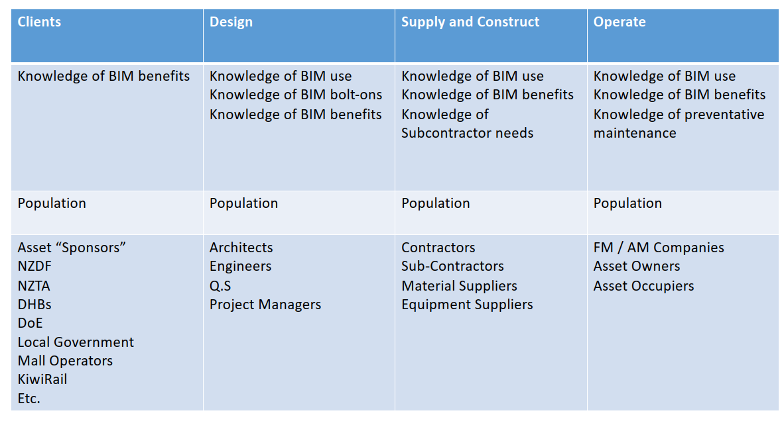
Appendix 1 – Knowledge Matrix

