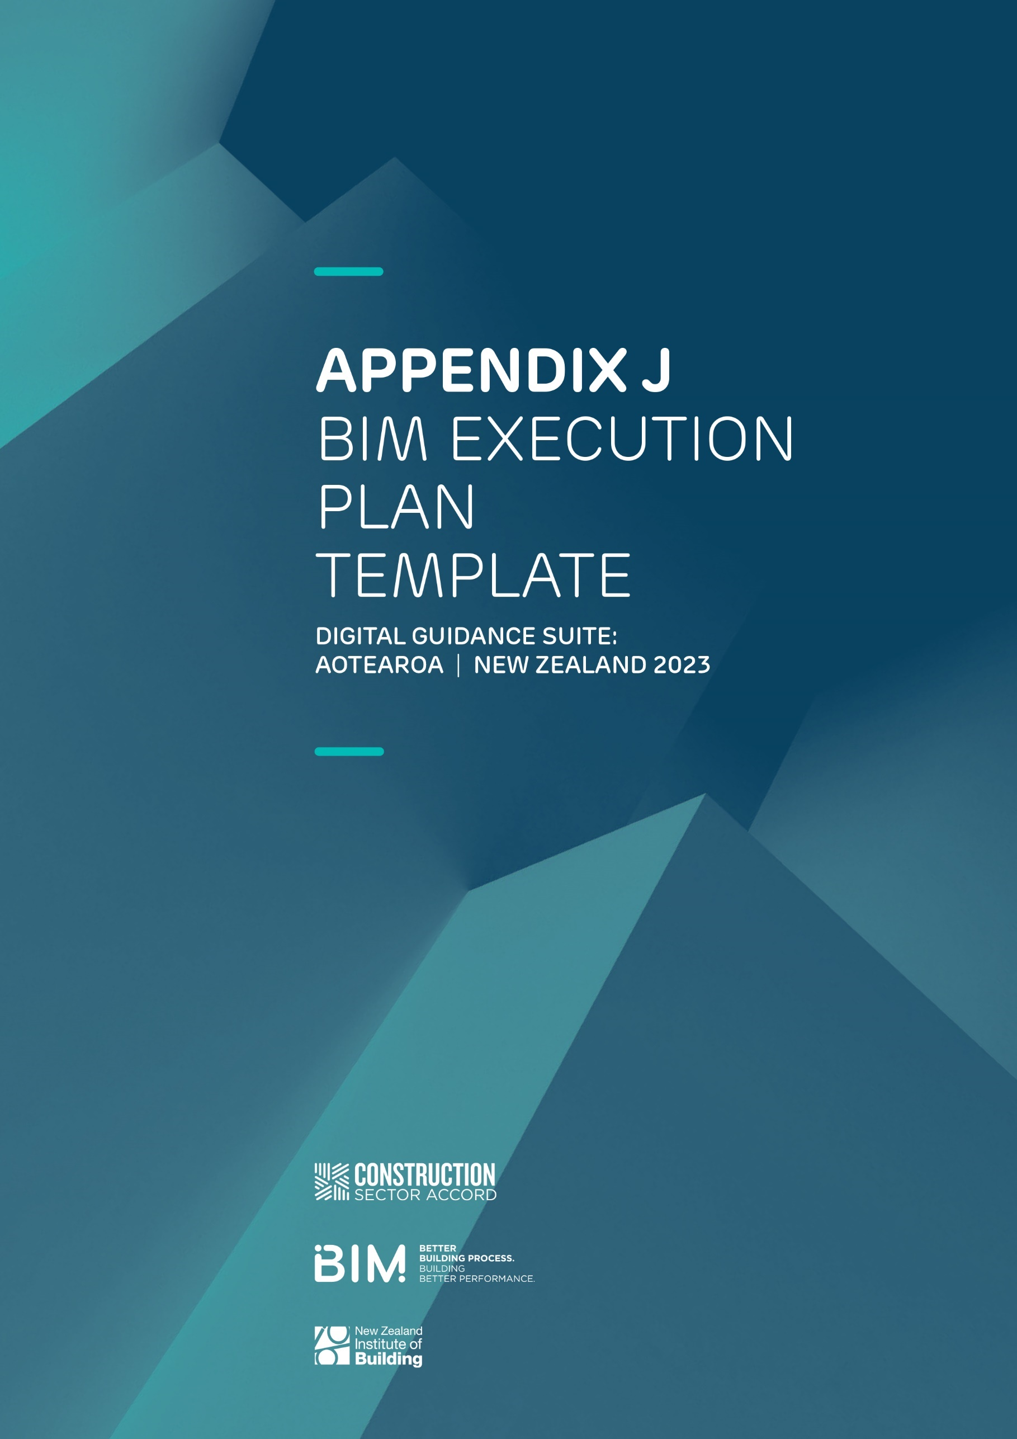

Table of Contents
1— General 4
2— BIM Vision and Objectives 5
3— Roles and Responsibilities 6
4— Information Requirements 8
5— Information Standards 11
6— Information Delivery 12
7— Technical – Collaboration 13
8— Technical – Modelling 14
9— Technical – Model Coordination 16
10— Appendices 18

Guidance notes throughout this document are written in red text,
these will need to be either revised or deleted prior to issue.

Introduction
To support BIM implementation on the (project name) project, (consultant or contractor name), in conjunction with the design and/or construction team stakeholders, has developed the following BIM Execution Plan.
This BIM Execution Plan defines who is responsible for what in the BIM process, when in the process they are responsible for it, and how they will execute it. This BIM Execution Plan has been structured to provide a framework for the creation and progression of Building Information Models to meet clients’ information requirements for the project and defines how information will be produced and managed during design delivery to support the following project outcomes:
Design:
- A reduction in errors and omissions during design through improved coordination
- Enhanced stakeholder engagement using static and interactive visualisations
- An accurate integration of the new design with the existing facility
- A consistent platform to house key information to be transferred into O&M
- Improved cost certainty during design
- Improved Safety in Design through using the 3D model to inform the SiD process

Construction:
- Reduced defects captured early during construction and commissioning phases
- All as-built information is provided shortly after Practical Completion (i.e. not delayed)
- Information captured is relevant to operational needs

Operation:
- Asset data made available at handover
- Accurate as-built documentation, including on location of critical assets

This BEP template can be used as a framework for the development of a BEP for specific construction project/s.
The BIM execution plan should be developed with reference to the New Zealand BIM Handbook.

1— General
Project Information
PROJECT NAME | Enter here
PROJECT OWNER | Enter here
PROJECT ADDRESS/LOCATION | Enter here
PROJECT REFERENCE | Enter here

Key Project Contacts
ROLE | COMPANY NAME | CONTACT NAME | EMAIL
CLIENT REPRESENTATIVE
PROJECT MANAGER
QUANTITY SURVEYOR
BIM MANAGER
ARCHITECT
ARCHITECT BIM LEAD
STRUCTURAL ENGINEER
STRUCTURAL BIM
ENGINEER
OTHER DESIGN LEADS
OTHER BIM LEADS

2— BIM Vision and Objectives

BIM USES AND RESPONSIBLE PARTIES
The following BIM uses have been identified by (client, consultant, etc.) as being able to support the achievement of the project outcomes defined at the start of this document. The table defines the desired benefits of BIM for this project, how the benefits are to be achieved, the applicable BIM uses, and the party responsible.

BIM BENEFIT | ACHIEVED HOW? | BIM USES | RESPONSIBLE PARTY
Design Transparency: Provide a high degree of transparency of the overall de-sign, improving coordination between stakeholders and improving delivery regarding time, cost, and quality. Supporting the delivery of briefed requirements. | All relevant data is contained within a Common Data Environment (CDE) for all key design information.  The delivery team meets regularly to review and solve issues using BIM processes and tools.
Design Quality: Improve design quality and reduce clashes and coordination issues prior to construction to reduce the number of Requests for Information (RFIs) and minimise the number of design- related issues. | The design geometry and data viewed through BIM tools are delivered in a consistent basis throughout the project, becoming the key source of design information for the wider project team.  Where applicable, drawings are derived from 3D models.  Reduction in number of site RFIs or delays caused by poor design coordination.  Clashes on site minimised or eliminated by early identification and mitigation prior to Issued for Construction (IFC) documentation.
Procurement & Construction: Improve the performance in procurement and construction through BIM processes. | Procurement of subcontractors is improved by issuing and  demonstrating the scope of works through 3D models and extracts from BIM, including for quantity and cost estimations.  Key temporary and permanent works planning and coordination issues on site can be identified and mitigated early for a more efficient construction process.
Digitise the handover and completions process: Use BIM processes to facilitate the transfer of design and construction data to the Asset Management System (AMS). | Successful transfer of asset information to (client) at handover stage.

3— Roles and Responsibilities

PROPOSED BIM ORGANISATIONAL CHART
Insert org. chart as applicable to the project. Refer to the NZ BIM Handbook for an overarching example.

RACI MATRIX
Our proposed roles and responsibilities to meet the requirements of the EIR are detailed in the RACI matrix below. Where there is shared accountability or responsibility, this relates to decisions that require multiple layers of approval, such as: a design coordination issue that is picked up by the BIM manager that also requires approval from the engineering lead or the design manager. It is important that BIM is fully embedded in the design team, and this is why some items show shared responsibility and/or accountability.
Update the RACI Matrix below to be specific to the project.

FUNCTIONS |  | ACTIVITIES & DELIVERABLES | CLIENT | CLIENT BIM ADVISOR  (Where applicable) | BIM  MANAGER  (Design/ Construction) | DISCIPLINE BIM LEAD | MODEL ELEMENT AUTHOR
Project Information Management |  | Develop the EIR and the end uses of information | A/R | R | C | I | I
 |  | Specify the Organisation Information Requirements and AIR | A/R | R | C | I | I
 |  | Confirm Asset Information deliverables | A | R | C | C | I
 |  | Confirm GIS deliverables | A | R | C | I | I
 |  | Confirm information standards and procedures | A | R | C | C | I
 |  | Set the requirements for the Common Data Environment CDE | A | R | R/C | C | I
 |  | Set the requirements for project deliverables | A | R | R/C | C | I
 |  | Lead BIM delivery on the project | C | A | R | R/C | R/C

KEY |  | R - Responsible for doing the activity | A - Accountable for activity completion | C - Consulted during activity | I - Informed following activity completion

FUNCTIONS |  | ACTIVITIES & DELIVERABLES | CLIENT | CLIENT BIM ADVISOR  (Where applicable) | BIM  MANAGER  (Design/ Construction) | DISCIPLINE BIM LEAD | MODEL ELEMENT AUTHOR
BIM Management, Coordination |  | Lead the development and updates of the Project-Specific BIM Execution Plan | A/R | R | C | I | I
 |  | Develop Information for procurement activities | A/R | R | C | I | I
 |  | Facilitating the use of the project BIM Execution Plan | A | R | C | C | I
 |  | Setup of Survey Control Model | A | R | C | I | I
 |  | Coordination of federated models | A | R | C | C | I
 |  | Lead model auditing and clash management process through design and construction | A | R | R/C | C | I
 |  | Manage the coordination of as built/record modelling through handover | A | R | R/C | C | I
 |  | Set up and manage the ongoing use of issue tracking tools in the BIM environment | C | A | R | R/C | R/C
Model Development and Design Management |  | Developing model files in accordance with the project BIM Execution Plan | I | C | C | A | R
 |  | Modelling elements at the appropriate Level of Development as defined in the Project BIM Execution Plan | I | I | I | A | R
 |  | Developing and validating as-built record model files in accordance with the project BIM Execution Plan | I | C | C | A | R
 |  | Validating Levels of Model Development at each project design stage | I | C | C | A | R
 |  | Communicating issues to Model Element Authors and leading issue resolution | I | I | A/R | C | C
 |  | Implementing discipline-specific coordination and clash detection procedures | I | I | I | A | R
 |  | Model transfer and version control | I | C/R | A | R | R
Collaboration and General Communication |  | Establish the Common Data Environment | I | A | R | C | C
 |  | Set up and drive a culture of collaboration when using BIM processes and tools on the project | I | I | A/R | R/C | C
 |  | Facilitate BIM meetings and workshops as required during the project | C | C | A/R | C | C
 |  | Clearly communicate information to the BIM team, Project Managers and the Design Leads as required | I | I | A/R | C | C
 |  | Communicate design coordination issues to project stakeholders | I | I | A/R | R/C | I
 |  | Communicate as-built/record modelling issues and progress to project stakeholders. | A | R | C | I | I
Key Meetings |  | BIM Requirements Kick-Off | C | C | A/R | R/C | C
 |  | BIM Execution Plan Workshop | C | C | A/R | R/C | C
 |  | Internal Model Coordination | I | I | A/R | A/R | C
 |  | BIM Coordination Review | I | I | A/R | R | C
 |  | Issue Tracking Software workshop | I | I | A/R | R | C

KEY |  | R - Responsible for doing the activity | A - Accountable for activity completion | C - Consulted during activity | I - Informed following activity completion

4— Information Requirements
ASSET INFORMATION REQUIREMENTS
Insert the asset information requirements that will be delivered as part of the project. Refer to the NZ BIM Handbook for further information.

PROJECT INFORMATION REQUIREMENTS
Detail project information requirements as applicable to the project.

Concept Design
# |  | INFORMATION PURPOSE | 3D MODEL | VISUALISATION | 2D.PDF DRAWINGS/ SKETCH | 2D.DWF DRAWING FILES | TABULAR DATA (.XML) | DIGITAL DOCUMENTATION
1 |  | Concept design optioneering
2 |  | Concept design cost estimate
3 |  | Client review and  concept design  approval
4
5

Preliminary Design
# |  | INFORMATION PURPOSE | 3D MODEL | VISUALISATION | 2D.PDF DRAWINGS/ SKETCH | 2D.DWF DRAWING FILES | TABULAR DATA (.XML) | DIGITAL DOCUMENTATION
1 |  | Preliminary design coordination
2 |  | Preliminary design cost estimate
3 |  | Client review and preliminary design approval
4
5

Developed Design
# |  | INFORMATION PURPOSE | 3D MODEL | VISUALISATION | 2D.PDF DRAWINGS/ SKETCH | 2D.DWF DRAWING FILES | TABULAR DATA (.XML) | DIGITAL DOCUMENTATION
1 |  | Safety in  Design review
2 |  | Developed design coordination
3 |  | Developed design cost estimate
4 |  | Client review and Developed design approval
5

Detailed Design
# |  | INFORMATION PURPOSE | 3D MODEL | VISUALISATION | 2D.PDF DRAWINGS/ SKETCH | 2D.DWF DRAWING FILES | TABULAR DATA (.XML) | DIGITAL DOCUMENTATION
1 |  | Safety in  Design review
2 |  | Developed design coordination
3 |  | Developed design cost estimate
4 |  | Client review and Developed design approval
5

Construction/Fabrication Design
# |  | INFORMATION PURPOSE | 3D MODEL | VISUALISATION | 2D.PDF DRAWINGS/ SKETCH | 2D.DWF DRAWING FILES | TABULAR DATA (.XML) | DIGITAL DOCUMENTATION
1 |  | Vendor integration
2 |  | Construction/Fabrication design coordination
3 |  | On-site Safety in Design review
4
5
Handover
# |  | INFORMATION PURPOSE | 3D MODEL | VISUALISATION | 2D.PDF DRAWINGS/ SKETCH | 2D.DWF DRAWING FILES | TABULAR DATA (.XML) | DIGITAL DOCUMENTATION
1 |  | Asset Information System population
2 |  | O&M integration
3 |  | Commissioning
4 |  | Client review and Developed design approval
5

GRAPHICAL INFORMATION REQUIREMENTS (LOD)
Typically, the following Levels of Development will apply to the project at each phase in accordance with the ticks in the table below. For further detail on the Levels of Development for specific elements, refer to Appendix ‘X’. (Insert appendix as required)

DESIGN |  |  |  |  |  |  |  |  |  | CONSTRUCTION |  |  |  | OPERATION
Concept Design |  | Prelim. Design |  | Developed  Design |  | Detailed Design |  | Construction  Issue |  | Shop Drawings and Fabrication Modelling |  | As-built Drawings  and Modelling |  | Asset/Facilities Management Model
100 | ✓ | 100 | ✓ | 100 | - | 100 | - | 100 | - | 100 | - | 100 | - | 100 | -
200 | - | 200 | ✓ | 200 | ✓ | 200 | - | 200 | - | 200 | - | 200 | - | 200 | -
300 | - | 300 | - | 300 | ✓ | 300 | ✓ | 300 | ✓ | 300 | - | 300 | - | 300 | ✓
350 | - | 350 | - | 350 | - | 350 | - | 350 | - | 350 | ✓ | 350 | ✓ | 350 | ✓
400 | - | 400 | - | 400 | - | 400 | - | 400 | - | 400 | ✓ | 400 | ✓ | 400 | ✓

INFORMATION SECURITY
This section should contain specific client or project requirements for information security.
It could include:
- Details of any specific security briefings that are required to be completed
- Access rights for information stored in the CDE
- The use of a cloud-hosted CDE platform vs an on-premises CDE platform

5— Information Standards
STANDARDS AND GUIDELINES
The core standards and guidelines that are to be used in this project are:

TYPE | TITLE | VERSION
Information management | ISO 19650-2 | 2018
Information requirements | BIM Forum Level of Development Specification | 2022
Modelling guideline | Client modelling standard/guideline | TBC

BIM OBJECT CLASSIFICATION
To aid interoperability in BIM authoring tools, coordination and collaboration platforms and the client’s asset management system (insert classification name) shall be adopted on the project.
Consider classification systems such as:
- Omniclass
- Uniclass
- VBIS

GENERAL FILE NAMING REQUIREMENTS
Examples below. Insert client requirements if applicable. This may also be documented in a different client standard, which will be referenced in the table above.

CHARACTERS
Names and naming fields shall include only the following characters:
- Uppercase letters (A to Z) from the ISO basic Latin alphabet
- Lowercase letters (a to z) from the ISO basic Latin alphabet
- Numbers (0 to 9)
- Underscore (_), used only for separating fields within a name
- A single period character (.), used only to separate the file name from the file extension
Names and naming fields shall not include any of the following characters:
- Symbols or mathematical operators, including, but not limited to, ! “ ,£ $ % ^ & * { }[ ] + = < > ? |\ / @ ’ ~ #¬ ` ‘
- Spaces
The use of the hyphen character should be avoided as it can cause errors when the name is used within formulas, for example calculating quantities or bills of materials, due to the hyphen also representing the mathematical subtraction symbol.

MODEL NAMING CONVENTION
To ensure consistency, model file naming will be as follows:
Insert client requirements if applicable
The naming convention is required to be followed by the prospective design consultants and/or construction contractor as it will allow for easy identification of the authoring discipline, the authoring party, and the asset to which the information relates.

6— Information Delivery

SCHEDULE OF MILESTONE INFORMATION EXCHANGES AND DELIVERABLES
The following table details the requirements for key project milestone information exchanges and deliverables.
PROJECT STAGE |  | BIM MILESTONE | DATE | MILESTONE EXCHANGE/ DELIVERABLES
Concept Design |  | Client review and concept design approval | Refer to Project  Programme | Concept design sketches
Prelim. Design |  | Client review and preliminary design approval |  | Preliminary design drawings  Preliminary design models  Schedules
Developed Design |  | Client review and developed design approval |  | Developed design drawings  Developed design models  Schedules
Detailed Design |  | Issued for construction |  | Detailed design drawings  Detailed design models  Schedules
Fabrication |  | Shop drawings and fabrication |  | Fabrication drawings  Fabrication models  Schedules

SCHEDULE OF DESIGN DEVELOPMENT INFORMATION EXCHANGE FORMATS
The following table details the file format for model exchanges to support ongoing design development and coordination. Design models are to be issued as (file format) format so that collaboration can occur in (collaboration platform).
PURPOSE/USE | DETAILS | FORMAT
Design Models | (Software platform) for design authoring and ongoing coordination purposes
Federated (Coordination) Model | (Software platform) for detailed coordination and clash- detection purposes
Documents | Model Description Documents, Model Audit Reports, Model Review Checklists
DESIGN DEVELOPMENT BIM EXCHANGE FREQUENCY
Models are to be shared weekly on (day and time) via the project CDE. The following table details the frequency of model exchanges to support ongoing design development and coordination
DISCIPLINE |  | CONCEPT DESIGN | PRELIMINARY/ DEVELOPED DESIGN | DETAILED DESIGN | CONSTRUCTION
Architectural |  | Fill column as needed | Fill column as needed | Fill column as needed | Fill column as needed
Structure |  | - | - | - | -
Mechanical |  | - | - | - | -
Hydraulic |  | - | - | - | -
Electrical |  | - | - | - | -
Fire |  | - | - | - | -
Fabrication |  | - | - | - | -

7— Technical – Collaboration
COMMON DATA ENVIRONMENT
Insert the CDE requirements, including workflow and access, that will be adopted during the delivery of the project. Refer to the NZ BIM Handbook for further information.
SCHEDULE OF BIM MEETINGS
We have identified the following BIM meetings for the project.

MEETING TYPE |  | FACILITATOR | PROJECT STAGE | FREQUENCY | REQUIRED ATTENDEES
KICK-OFF MEETING |  | BIM Manager | Project Kick-off | One off | All
ONGOING BIM EXECUTION PLANNING |  | BIM Manager | As required | As required | BIM Manager, BIM Coordinator, Discipline BIM Leads
3D DESIGN REVIEWS |  | Design Lead, Discipline BIM Lead | Preliminary, HAZOP and Detailed Design | Aligned with design team meetings | Full design team
BIM COORDINATION MEETING (VISUAL) |  | BIM Manager | Preliminary Design | TBC | Full design team
BIM COORDINATION MEETINGS |  | BIM Manager | Detailed Design | Fortnightly | Full design team

8— Technical – Modelling
SOFTWARE VERSIONS
The software versions that will be used for the duration of the project are as follows:
SOFTWARE | VERSION | DISCIPLINES INVOLVED

SPECIFIC SOFTWARE REQUIREMENTS
Insert specific software requirements that will be adopted during the delivery of the project.
FEDERATED MODEL STRUCTURE
Insert a diagram showing the federated model structure that will be adopted during the delivery of the project. Refer to the NZ BIM Handbook for an example.
MEASUREMENT AND COORDINATE SYSTEM
Insert details of the coordinate system and applicable survey control points that will be adopted during the delivery of the project.
MODELLING FOR COST ESTIMATION
Information exported from the design intent models will be provided to the quantity surveyor to support the traditional estimation process when required, drawings will take precedence for the purpose of costing.
The intention of this approach is to add value through the provision of additional information to support the estimate.
To schedule as much information as possible from the models, in addition to following the NZIQS Australia and New Zealand BIM Best Practice Guidelines for modelling, the following are required:
- Staging to be demarked in model objects e.g. demolished, new build, existing
- Typical details/bays/typical sections (items replicated but modelled in only one area) are to be excluded from the export
- The cost manager is to be included in all review processes throughout design progression
- Items such as connections/walls to be demarked with 2D detail references
- Any placeholder items to have indicative specifications and sizes included in the object
- 2D sheets linked to the 3D model
- Any major changes to the design are to be made in the model rather than solely on the 2D drawings
QUANTITY SURVEYOR RESPONSIBILITIES
The quantity surveyor is ultimately responsible for the accuracy of the estimate, including making allowance for all non-modelled construction costs such as (but not limited to) design complexity, constructability, material supply, waste, and non-modelled specified items. The quantity surveyor is also responsible for all costs and other allowances such as (but not limited to) preliminaries, margins, escalation, procurement, contingencies, consents, consultant costs and other client-side costs.
MODEL QUALITY CONTROL CHECKS
The following checks should be performed to assure quality within models and information, eliminate errors, and achieve desired project outcomes.
These checks are intended to be carried out internally by the discipline BIM lead.
CHECK |  | DEFINITION | RESPONSIBLE PARTIES | PROJECT STAGE | FREQUENCY
Visual check |  | See that there are no unintended model components, and the design intent has been followed
Interference check |  | Detect problems in the disciplines model, where two components clash, including soft and hard
Model integrity checks |  | Ensure integrity of the model aligns with  BIM uses and a client’s BIM-specific modelling and documentation requirements and standards, as set out in the model standards
Design review |  | Ensure ongoing development of the model aligns with the client objectives
Authoring software warnings

MODEL EXCLUSIONS
Insert details of any model exclusions.

9— Technical – Model Coordination
MODEL COORDINATION STRATEGY
Insert details of the project model-coordination and clash-detection strategy, including workflow diagrams.

INTERNAL COORDINATION REVIEW
Each discipline will be responsible for implementing an internal coordination review system and carrying out self-reviews at regular intervals as appropriate for the discipline and the design effort being expended at that project stage.
Coordination issues identified that require input from other parties will be raised at the following design meeting at the latest. However, it is considered preferable to maintain open lines of communication and resolve issues directly via phone, email, or web conferencing. The design meeting can then be used to inform the wider design team of the proposed solution and ensure there are no unforeseen issues.
Issues identified because of internal coordination reviews may be entered into issue-tracking software as user-generated issues, if not already present.

COORDINATION MEETINGS
The following table details the coordination meetings across each stage of the project.
MEETING TYPE |  | FACILITATOR | PROJECT STAGE | FREQUENCY | REQUIRED ATTENDEES
Fill column as required |  | Fill column as required | Fill column as required | Fill column as required | Fill column as required

MODEL COORDINATION MATRIX
Insert details of the model coordination matrix and tolerances.
Refer to Appendix B of the NZ BIM Handbook for further information.
CLASH TYPES
Insert details of what ‘clashes’ are real clashes and what will be ‘ignored’. A building’s example is shown below.
The following table outlines the proposed approach to the identification of ‘clashes’ and whether these items are coordinated.

DESCRIPTION | CLASH EXAMPLE | CONSIDERED COORDINATED?
Structural Column and Floor | 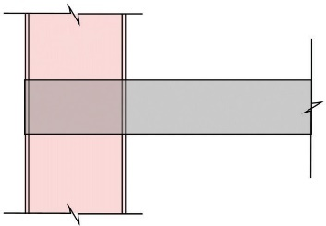 | Yes (modelling artifact- not a real clash)
Structural beam penetration and pipework  Truss member and services | 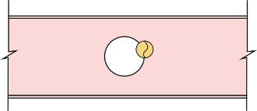  Pi Pipe fits penetration but not aligned in model | Yes (can be resolved during the shop drawing process or on site)
 | 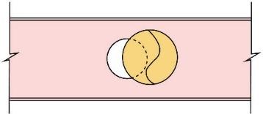  Pipe does not fit penetration | No (cannot be resolved during the shop drawing process or on site)
 | 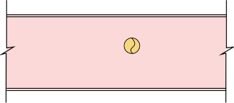  No penetration provided (no detail in 2D details either) | No
 | 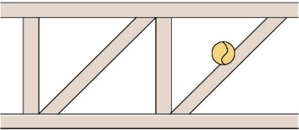  Duct clashes with truss diagonal; however, spatially fits | Yes (can be resolved during the shop drawing process or on site)
 | 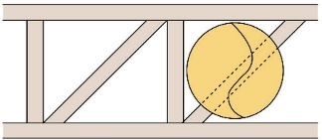 | No (cannot be resolved during the shop drawing process or on site)
Clash of flexible duct and tray | 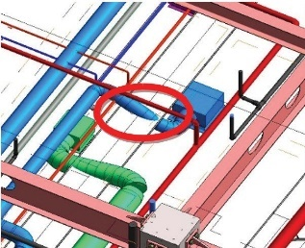 | Yes (not considered a clash as the flexible duct can be moved on site)

ISSUE MANAGEMENT AND TRACKING
Insert details of the process for tracking and resolving BIM issues. Consider including:
- Software used
- Issue priority rating
- Issue filtering

10— Appendices
Consider including the following as appendices to the BIM Execution Plan.
- Level of Development – detailing the model-element authors and levels of development for the project
- Issue Management – detailing the workflow for the issue-management process
- CDE Workflow – detailing the workflow for using the Common Data Environment
- Master Information Delivery Plan – detailing the project-wide BIM deliverables list, responsible parties, and deadlines
- Shared Resources – detailing which shared resources are available and applicable to the project
- Clash Matrix – detailing which elements will be coordinated with one another, the priority of the issues, and the tolerances between different element types/disciplines types/disciplines

