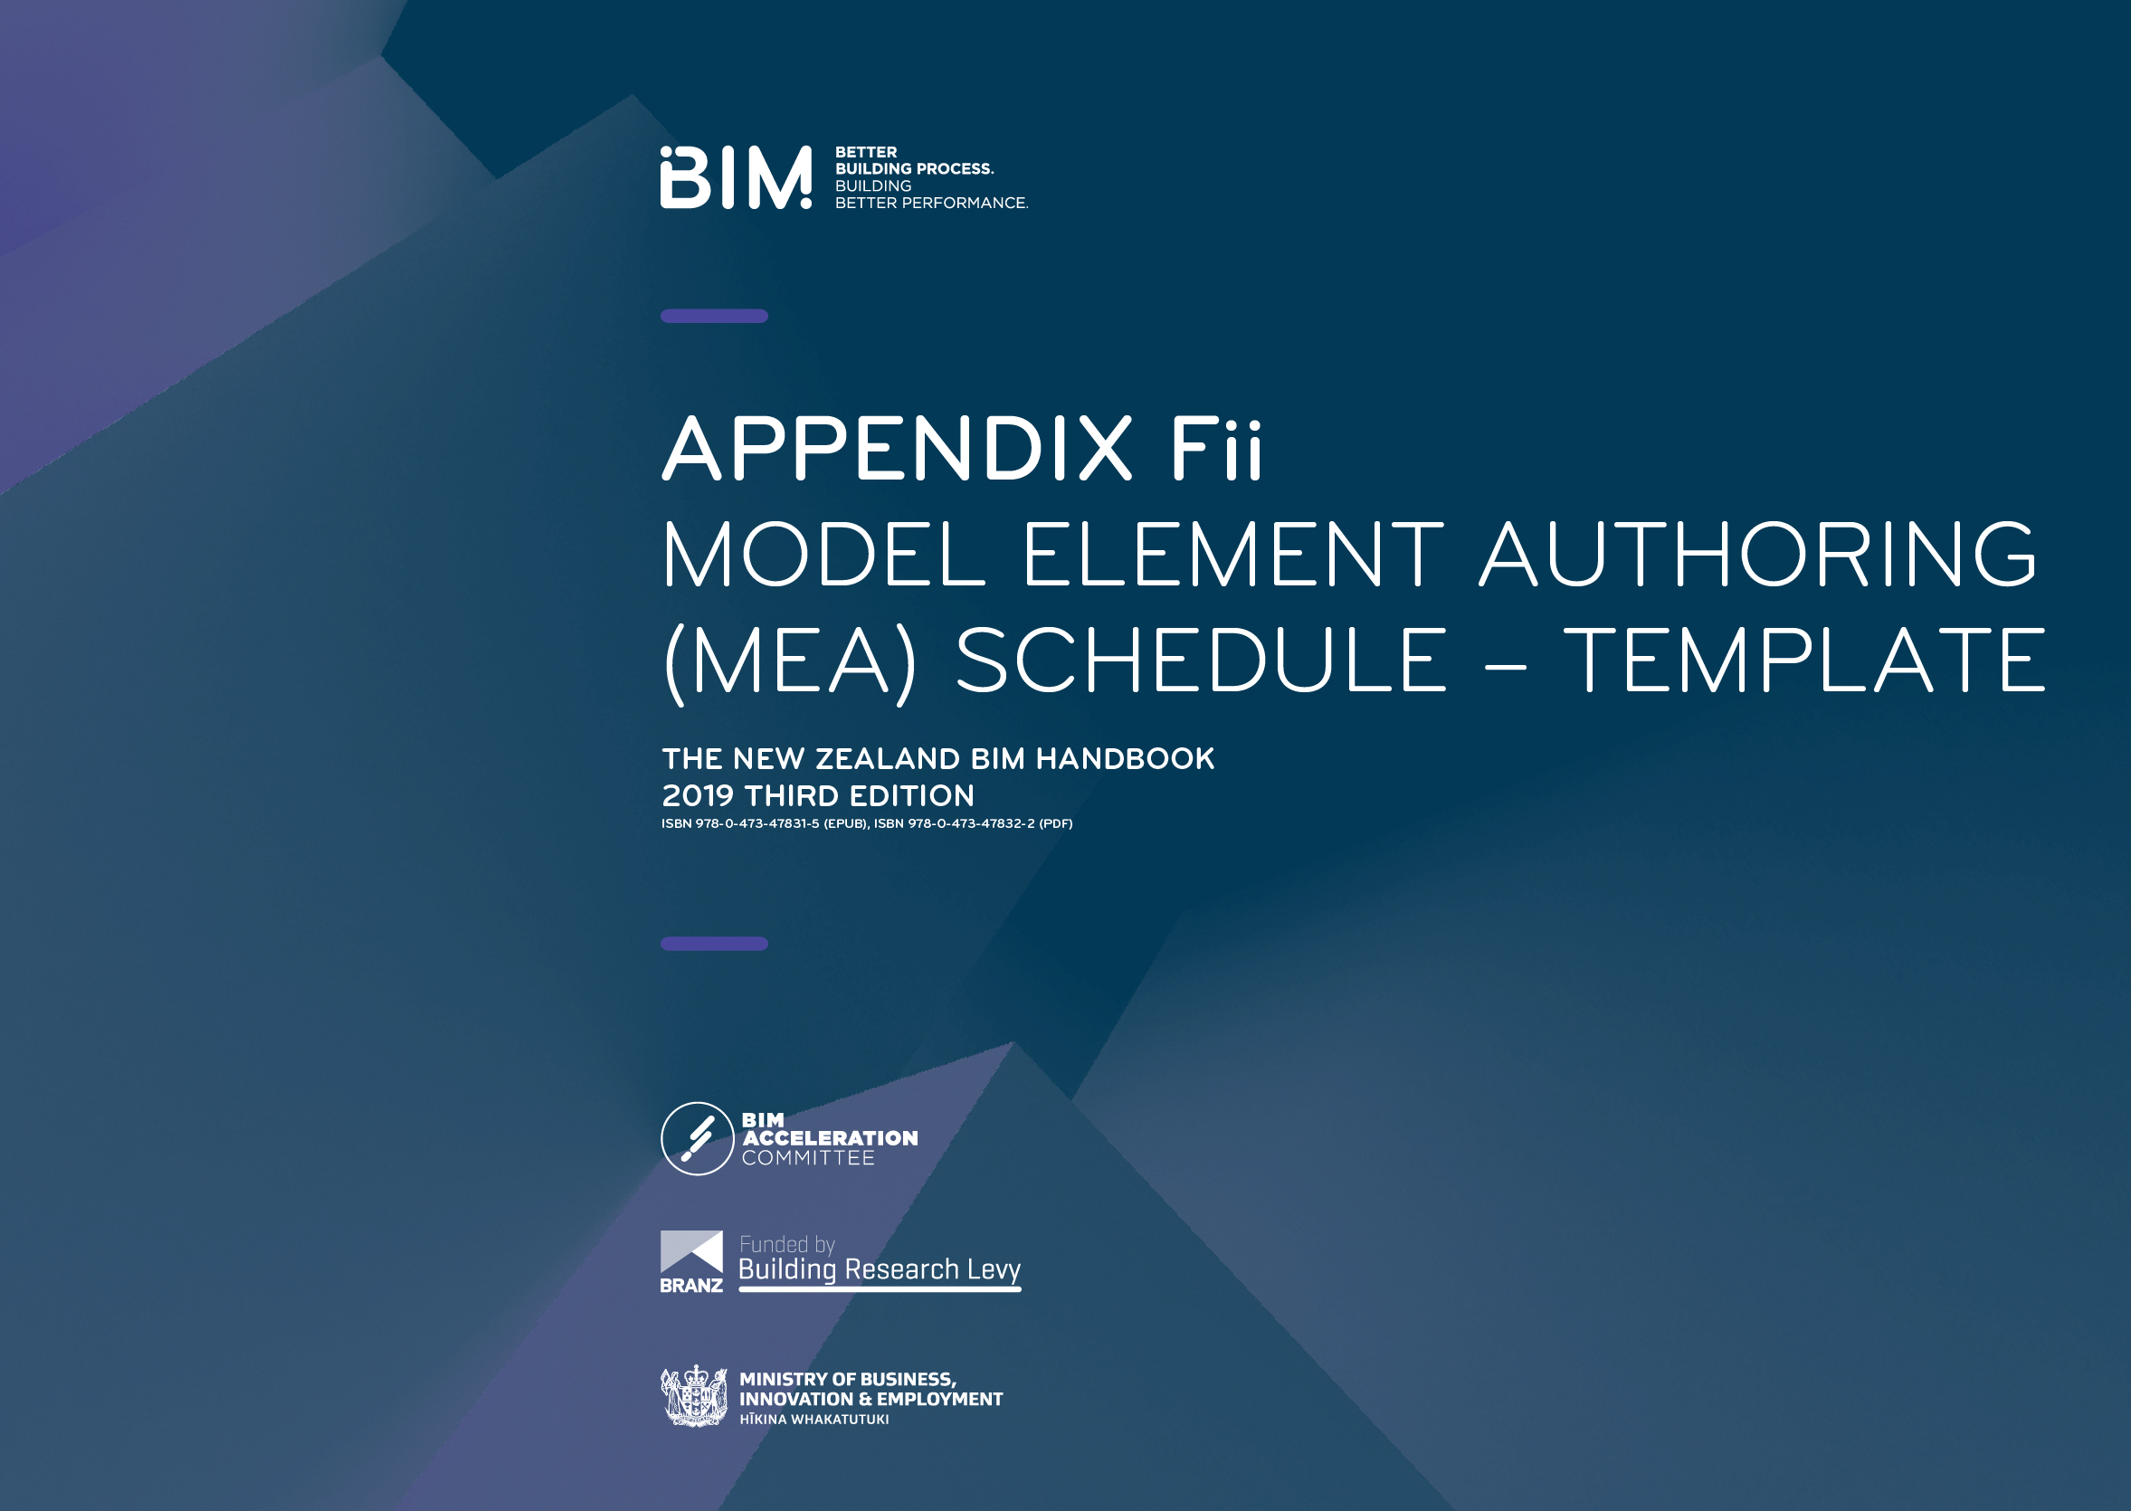
Model element authoring schedule – template

This schedule assigns responsibilities to model elements via an author (MEA) and defines Level of Development (LOD) for those model elements across project stages. Find detailed definitions in Appendix C Levels of Development.
Model elements ownership can be transferred between participating parties, but should be clearly defined in the table below.
This MEA schedule is a starting point for a standard project and the selection of elements in the schedule. It should reflect individual project requirements
and be agreed by participating parties.
REVISION RECORD
REVISION: | DATE: | REVIEWER: | COMMENTS:

MEA DISCIPLINE: |  |  | LEVEL OF DEVELOPMENT (LOD): | REFER TO NEW ZEALAND BIM HANDBOOK  FOR DEFINITIONS:
ARCHITECTURE |  |  | 100 | Conceptual
STRUCTURE |  |  | 200 | Approximate geometry
HYDRAULIC |  |  | 300 | Design specified system (Precise geometry)
OTHER |  |  | 350 | Specific system (precise geometry) + Interfaces
 |  |  | 400 | Fabrication and assembly
 |  |  | 500 | Field verified

Project participants are responsible for developing each model element, at the end of each phase of the project, to the Level of Development (LOD) as set out below, with reference to the BIM Forum Level of Development (LOD) specification.
Project phase: | Concept design |  | Preliminary design |  | Developed design |  | Detailed design |  | Construction |  |  | Operation |  |  | Notes
Model element: | MEA | LOD | MEA | LOD | MEA | LOD | MEA | LOD | MEA | LOD |  | MEA | LOD
SPATIAL:
SITE BOUNDARIES, SETBACKS
GRIDS
LEVELS
ZONES
SPACES, ROOMS
SITE
TOPOGRAPHY
EXCAVATION
STORMWATER
SERVICES (IN GROUND)
ROADS |  |  |  |  |  |  |  |  |  |  |  |  |  |  | Transfer design content from ARCH - CIVIL
PARKING
PATHS, PAVING, KERBS
WALLS |  |  |  |  |  |  |  |  |  |  |  |  |  |  | Non-loadbearing
FENCING
SOFT LANDSCAPING

Project phase  DELIVERABLE: | Concept design |  | Preliminary design |  | Developed design |  | Detailed design |  | Construction |  |  | Operation |  |  | Notes
Model element: | MEA | LOD | MEA | LOD | MEA | LOD | MEA | LOD | MEA | LOD |  | MEA | LOD
SUBSTRUCTURE:
FOUNDATIONS
RETAINING WALLS |  |  |  |  |  |  |  |  |  |  |  |  |  |  | Architect to specify and set out. Structure to provide support. Duplicated elements to be discussed
SUBSOIL DRAINAGE
SLAB ON GRADE |  |  |  |  |  |  |  |  |  |  |  |  |  |  | Architect to specify, set out and allow for rebates and setdowns. Structure to provide support. Structure to monitor architecture and own structural slabs. Duplicated elements to be discussed
STRUCTURE
FLOORS - CONCRETE |  |  |  |  |  |  |  |  |  |  |  |  |  |  | Slab edge & rebates ownership to be discussed
FLOORS - TIMBER
COLUMNS - CONCRETE
COLUMNS - TIMBER
COLUMNS - STEEL (PRIMARY)
COLUMNS - STEEL (SECONDARY) |  |  |  |  |  |  |  |  |  |  |  |  |  |  | Support posts
COLUMNS - STEEL (TERTIARY) |  |  |  |  |  |  |  |  |  |  |  |  |  |  | Architectural support steelwork, such as facade support
BEAMS - CONCRETE
FRAMING - TIMBER
FRAMING - STEEL (PRIMARY) |  |  |  |  |  |  |  |  |  |  |  |  |  |  | Beams, bracing
FRAMING - STEEL (SECONDARY) |  |  |  |  |  |  |  |  |  |  |  |  |  |  | Support beams, purlins,  girts, architectural support steelwork, such as facade support
WALLS - LOAD BEARING |  |  |  |  |  |  |  |  |  |  |  |  |  |  | Duplicated elements to be discussed
WALLS - INSITU CONCRETE |  |  |  |  |  |  |  |  |  |  |  |  |  |  | Plinths, upstands/nibs, recesses
WALLS - MASONRY |  |  |  |  |  |  |  |  |  |  |  |  |  |  | Duplicated elements to be discussed
WALLS - PRECAST CONCRETE
PENETRATIONS - SHAFT
PENETRATIONS - WALL |  |  |  |  |  |  |  |  |  |  |  |  |  |  | Load bearing
PENETRATIONS - SERVICES |  |  |  |  |  |  |  |  |  |  |  |  |  |  | Define the minimum size
STAIRS - CONCRETE |  |  |  |  |  |  |  |  |  |  |  |  |  |  | Architect to setout & cover compliance
STAIRS - STEEL
RAMPS
ROOF - CONCRETE |  |  |  |  |  |  |  |  |  |  |  |  |  |  | Rebates & upstands included
NON-STRUCTURAL SEISMIC RESTRAINTS

Project phase  DELIVERABLE: | Concept design |  | Preliminary design |  | Developed design |  | Detailed design |  | Construction |  |  | Operation |  |  | Notes
Model element: | MEA | LOD | MEA | LOD | MEA | LOD | MEA | LOD | MEA | LOD |  | MEA | LOD
ENCLOSURE
CLADDING
CURTAIN WALLS
WINDOWS
DOORS
WALL OPENINGS
ROOFING
ROOF OPENINGS
CANOPIES
COLUMN CLADDINGS
ACCESS & MAINTENANCE |  |  |  |  |  |  |  |  |  |  |  |  |  |  | Consider safety in design  and maintenance purposes elements
INTERIOR
FLOORING
WALLS - INTERTENANCY
WALLS - PARTITIONS
WALLS - FINISHES
DOORS
INTERNAL OPENINGS |  |  |  |  |  |  |  |  |  |  |  |  |  |  | Non structural
CEILINGS
BALUSTRADING

Project phase  DELIVERABLE: | Concept design |  | Preliminary design |  | Developed design |  | Detailed design |  | Construction |  |  | Operation |  |  | Notes
Model element: | MEA | LOD | MEA | LOD | MEA | LOD | MEA | LOD | MEA | LOD |  | MEA | LOD
F, F & E
CASEWORK, JOINERY
FIXTURES
FITTINGS
EQUIPMENT
(NON-SERVICE)
FURNITURE
SIGNAGE & WAYFINDING
MECHANICAL |  |  |  |  |  |  |  |  |  |  |  |  |  |  | Consider flanges, fixings, seismic movement to other elements
AIR TERMINALS |  |  |  |  |  |  |  |  |  |  |  |  |  |  | Registers, Grilles,  Diffusers etc)
MECHANICAL EQUIPMENT – MAJOR |  |  |  |  |  |  |  |  |  |  |  |  |  |  | Plant rooms
MECHANICAL EQUIPMENT – MINOR |  |  |  |  |  |  |  |  |  |  |  |  |  |  | On Floor
MECHANICAL LOUVRES
DUCTWORK - RISERS
DUCTWORK - MAJOR RUNS
DUCTWORK - BRANCHES
DUCTWORK EQUIPMENT CONNECTIONS
DUCTWORK ACCESSORIES |  |  |  |  |  |  |  |  |  |  |  |  |  |  | Dampers, collars, fire sleeves etc.
DUCTWORK FITTINGS
DUCTWORK - FLEXIBLE
PIPE ACCESSORIES – MAJOR VALVES
PIPE FITTINGS
PIPEWORK - RISERS |  |  |  |  |  |  |  |  |  |  |  |  |  |  | Greater than 30mm in diameter only (including Lagging/Insulation)
PIPEWORK - MAIN RUNS
PIPEWORK - BRANCHES
PIPEWORK - FINAL CONNECTIONS
PIPEWORK - FLEXIBLE
ELECTRICAL FOR MECHANICAL |  |  |  |  |  |  |  |  |  |  |  |  |  |  | MSSB or cable trays
MAINTENANCE & ACCESS ZONES AROUND EQUIPMENT
SEISMIC RESTRAINTS |  |  |  |  |  |  |  |  |  |  |  |  |  |  | Ownership to be discussed

Project phase  DELIVERABLE: | Concept design |  | Preliminary design |  | Developed design |  | Detailed design |  | Construction |  |  | Operation |  |  | Notes
Model element: | MEA | LOD | MEA | LOD | MEA | LOD | MEA | LOD | MEA | LOD |  | MEA | LOD
HYDRAULIC
SANITARY FIXTURES |  |  |  |  |  |  |  |  |  |  |  |  |  |  | Including FWG’s
HOT AND COLD WATER SYSTEMS
STORMWATER SYSTEMS
SIPHONIC SYSTEMS
SANITARY SYSTEMS
VENT SYSTEMS
HYDRAULIC EQUIPMENT -MAJOR
HYDRAULIC EQUIPMENT - MINOR
PIPE ACCESSORIES – MAJOR VALVES
PIPE FITTINGS |  |  |  |  |  |  |  |  |  |  |  |  |  |  | Bends, Tees etc
PIPEWORK - RISERS
PIPEWORK - MAIN RUNS
PIPEWORK - BRANCHES
PIPEWORK - FINAL CONNECTIONS
MAINTENANCE & ACCESS ZONES AROUND EQUIPMENT
SEISMIC RESTRAINTS |  |  |  |  |  |  |  |  |  |  |  |  |  |  | Ownership to be discussed
FIRE PROTECTION
SPRINKLER HEADS
FIRE EQUIPMENT |  |  |  |  |  |  |  |  |  |  |  |  |  |  | Pumps/Tanks/etc
FIRE ALARM CONTROLS
FIRE PANELS - MAJOR
FIRE PANELS - MINOR
PIPEWORK - RISES
PIPEWORK - MAINS
PIPEWORK - BRANCHES
PIPEWORK - FLEXIBLE
PIPE ACCESSORIES - SPRINKLER VALVE SETS
PIPE ACCESSORIES - VALVES
Passive Fire Protection |  |  |  |  |  |  |  |  |  |  |  |  |  |  | Dampers, collars etc
MAINTENANCE & ACCESS ZONES AROUND EQUIPMENT
SEISMIC RESTRAINTS |  |  |  |  |  |  |  |  |  |  |  |  |  |  | Ownership to be discussed

Project phase  DELIVERABLE: | Concept design |  | Preliminary design |  | Developed design |  | Detailed design |  | Construction |  |  | Operation |  |  | Notes
Model element: | MEA | LOD | MEA | LOD | MEA | LOD | MEA | LOD | MEA | LOD |  | MEA | LOD
ELECTRICAL/ SECURITY
ELECTRICAL EQUIPMENT - MAJOR
ELECTRICAL EQUIPMENT - MINOR
ELECTRICAL FIXTURES
GPOS
CABLE TRAYS - RISERS
CABLE TRAYS - MAJOR RUNS
CABLE TRAYS - BRANCHES
LIGHTING - FIXTURES
LIGHTING - EMERGENCY & EGRESS
LIGHT CONTROLS |  |  |  |  |  |  |  |  |  |  |  |  |  |  | Switches
DATA OUTLETS
COMMS AND DATA EQUIPMENT - MAJOR
COMMS AND DATA EQUIPMENT - MINOR
SECURITY DEVICES |  |  |  |  |  |  |  |  |  |  |  |  |  |  | PIR
SECURITY PANELS /EQUIPMENT - PRIMARY
Security Panels /Equipment - Secondary
MAINTENANCE & ACCESS ZONES AROUND EQUIPMENT
SEISMIC RESTRAINTS |  |  |  |  |  |  |  |  |  |  |  |  |  |  | Ownership to be discussed
CONVEYING
LIFTS,
ESCALATORS
TRAVELATORS
MAINTENANCE & ACCESS ZONES AROUND EQUIPMENT
SPECIALIST SERVICES
NURSE CALL DEVICES
NURSE CALL PANELS
MEDICAL GAS
PANIC BUTTONS

Reference documents and standards
The following documents are listed for reference.
GENERIC TITLE: | APPLICABLE REFERENCE DOCUMENT/NOTES: | VERSION:
The New Zealand BIM handbook
This document is one of a suite of documents forming the New Zealand BIM handbook.
You can download or view the remaining documents here:
http://www.biminnz.co.nz/nz-bim-handbook

