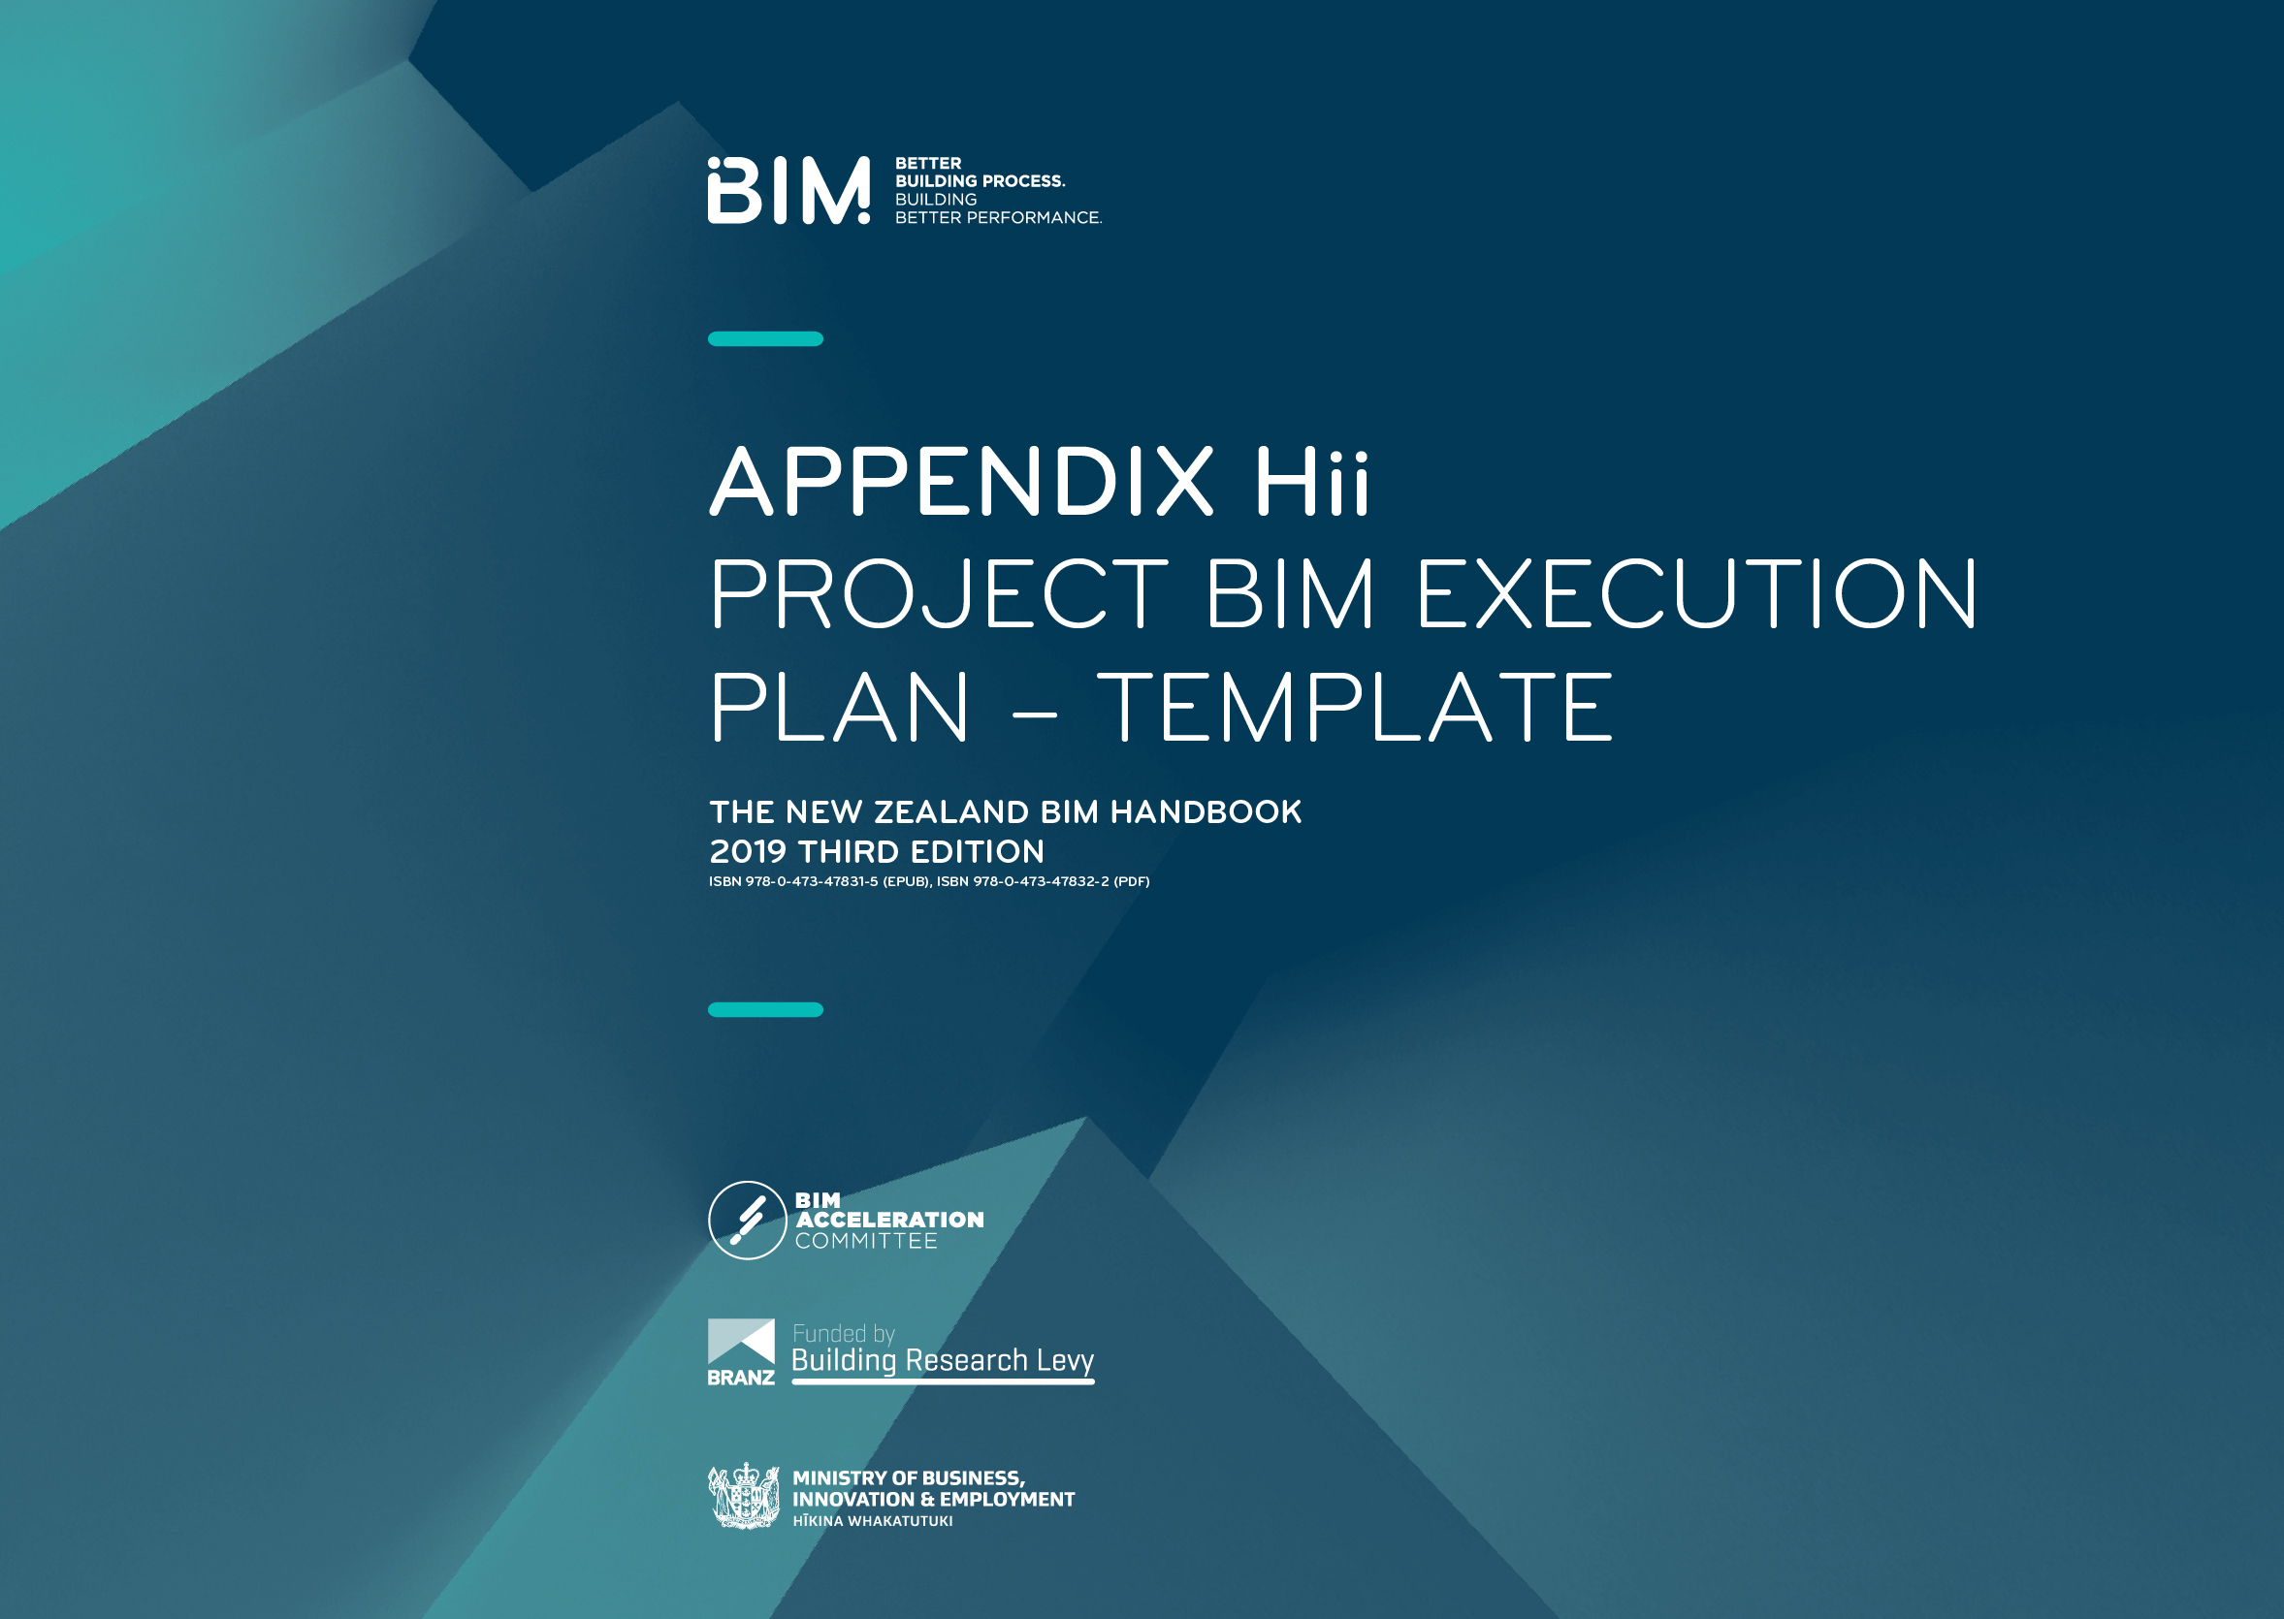
The project BIM Execution Plan (BEP) is a detailed plan that defines how the project will be executed, monitored, and organised with regard to BIM.

The intent of the BIM execution plan is to provide an outline that will ensure all parties involved are clearly aware of the opportunities and responsibilities associated with projects that implement BIM.
The plan defines why you are using BIM on the project. It sets goals, objectives, and responsibilities, and outlines how the process will be executed through the project life cycle.
The BIM execution plan is a living document and should be developed and refined throughout the project life cycle to ensure the project remains on schedule and meets the briefed requirements.
This BEP template can be used as a framework for the development
of a BEP for specific construction project/s.
The BIM execution plan should be developed with reference to
the New Zealand BIM handbook.

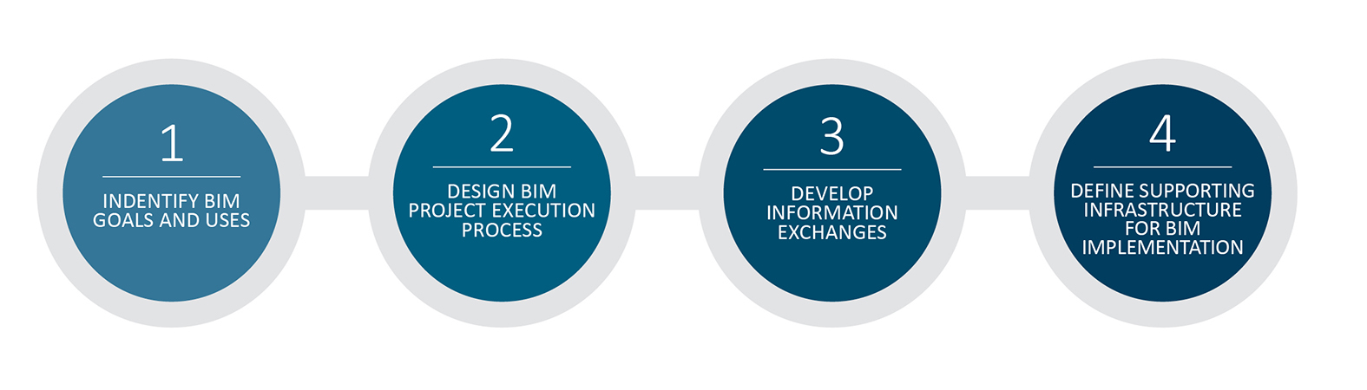

Table of contents

Revision record 5
Project information 5
Project schedule 6
Key project contacts 6
Project goals 7
BIM use responsible parties 8
Client required BIM uses for the project 8
Project team additional BIM uses for the project 8
Information management and exchange 9
Information exchange 9
Schedule of information exchange 10
Measurement and coordinate systems 10
Coordination model tolerance schedule 11
Model standards 11
Model structure 11
Model Description Document (MDD) 11
Permission and access 11
Collaboration 12
Schedule of meetings 12
Project deliverables 12
Quality control checks 13
Reference documents and standards 14

PREPARED BY: | COMPANY: | DATE:
Name | Name | 1/1/2019

Revision record
REVISION: | DATE: | REVIEWERs: | COMMENTS:

Project information
Project name:
Project owner:
Project address/location:
Brief project description:
Contract type/delivery method:
Contractor engagement
– indicative date:
HAS A PROJECT BIM BRIEF BEEN COMPLETED?

Project schedule
Complete the table below. Include major project milestones over the project lifecycle.
Project phase/milestone: | Estimated start date: | Estimated completion date: | BIM MEETINGS:
Project establishment
Concept design
Preliminary design
Developed design
Detailed design
Procurement
Construction
Handover
Operation

Key project contacts
List known key stakeholders who will be involved in BIM on this project.
Role: | Discipline: | Company name: | Contact name: |  | Contact details:
Client representative | NA
Project manager | NA
QUANTITY SURVEYOR | NA
BIM manager(s) | NA
Lead consultant
Discipline BIM leads
DISCIPLINE LEADS
Other project roles

Project goals
List client goals and expectations for the project. This table will help define BIM uses required for the project to remain aligned with the project goals.
Refer to Appendix D for BIM uses. Extract this information from the project BIM brief, and other associated documents.
Priority: | Goal description – value added objectives: | HOW: | BIM Uses:
(high/med/low)

BIM use responsible parties
The purpose of this table is to identify the responsible parties for BIM on the project. Refer to Appendix D for BIM uses.
Client required BIM uses for the project
Extract this information from the project BIM brief, or other associated documents. In the case a project BIM brief does not exist, use the project goals
table to help the select BIM uses based on project goals, team characteristics, and capability.
BIM Use: | Responsible parties: | cOMMENTS:

Project team additional BIM uses for the project
The project team may agree additional BIM uses likely to deliver benefits. Record this information in the table below.
BIM Use: | Responsible parties: | cOMMENTS:

Information management and exchange
Exchanging models is the basis of the BIM process. All users must understand the level of reliance that they can place on the models they are receiving.
The issuer of a model must clearly define what the model can (and can’t) be used for. A list of approved model statuses for a project includes:
a) Issued for information – issued for Information only
b) Work in progress – issued for ongoing coordination
Making this information available to others during the development of project will help maximise the benefits of BIM.
The use of the models should be clearly defined in a Model Description Document (MDD). Refer Appendix J.
Information exchange
Identify the responsible parties, design authoring software, and version to be used with the associated BIM uses, along with the collaboration file format the team will use in order to exchange models.
BIM Use: | Responsible parties: | SOFTWARE: | VERSION: | Intended collaboration file format:

Specify a file naming convention for exchanged models, the data sharing platform these files will be saved to, and any additional information that may be required.
DISCIPLINE: |  | FILE NAME: |  | Intended collaboration/data sharing platform: |  | Additional information:

Schedule of information exchange
INFORMATION EXCHANGE: | DISCIPLINE: | FREQUENCY: | DAY/ DATE:
All model exchanges should be accompanied by a Model Description Document (MDD). Refer to Appendix J.

Measurement and coordinate systems
Identify project spatial location (real-world coordinate and level system).
Project datum
Height datum
Project location | EASTING | NORTHING
Model positioning | DEGREES

Coordination model tolerance schedule
This project will use the coordination tolerances as shown in the table below (this table does not infer design tolerances):
Discipline | Concept Design | Preliminary Design | Developed Design | Detailed Design
Architectural vs other | N/A | ~100mm | ~50mm | ~25mm
Structural vs other | N/A | ~100mm | ~50mm | ~25mm
Mechanical vs other | N/A | ~100mm | ~50mm | ~25mm
Mechanical vs mechanical | N/A | ~100mm | ~50mm | ~25mm

Model standards
As a minimum, each discipline in the project team should model industry-proven, best-practice methodology, as well as comply with their in-house standards and protocols. However, the client may have specific modelling and documentation requirements and standards, which must be adhered to as part of the BIM deliverables. These should be specified below.
Model standards to be used

Model structure
Describe and produce a simple diagram to show how the model is separated. E.g. by building, floors, zone, model size, areas, and/or discipline.
Model Description Document (MDD)
Each modelling team should include a Model Description Document (MDD) or similar agreed document that includes crucial information for each model
it publishes. The document should describe the contents of the model, any major revisions/changes, and explain its purpose and limitations.
Permission and access
The following document management issues should be considered/resolved and a procedure defined for each: permissions/access, file locations,
CDE location(s), file transfer protocol, file/folder maintenance, etc.

Collaboration
Ensure the participating parties clearly define each person's role and functions with regard to BIM. Roles and functions are covered in the main body
of the BIM handbook.
Describe how the project team will collaborate. Include items such as the Common Data environment (CDE) for managing project information,
communication methods, transfer, and record storage, etc.
Discuss project team training requirements for chosen collaboration software and protocols.
Project based CDE

Schedule of meetings
MEETING TYPE | Facilitator | Project stage | Required attendees | Required technology | Frequency | Location
BIM requirements kick-off
BIM Execution Plan demonstration
Design coordination
Construction over-the-shoulder progress reviews
Any other BIM meetings

Project deliverables
In this section, list the BIM deliverables for the project and the format in which the information will be delivered.
BIM Use: | FROM: | TO: | Approximate  due date/ stage: | Format: | Comments:
Quality control checks
The following checks should be performed to assure quality within models and information, eliminate errors, and achieve desired project outcomes.
These checks are intended to be carried out internally by the BIM coordinator.
CHECK: | Definition: | Responsible parties: | Project stage: | Frequency:
Visual check | See that there are no unintended model components and the design intent has been followed
Interference check | Detect problems in the disciplines model, where  two components clash, including soft and hard
Model integrity checks | Ensure integrity of the model aligns with BIM uses and a client’s BIM specific modelling and documentation requirements and standards,  as set out in the model standards
Design review | Ensure ongoing development of the model aligns to the client objectives.
Authoring software warnings
Note: These processes don’t replace picking up the phone and talking to each other.

Reference documents and standards
The following documents are listed for reference.
Generic title: | Applicable reference document/notes: | Version:

The New Zealand BIM handbook
This document is one of a suite of documents forming the New Zealand BIM handbook.
You can download or view the remaining documents here:
http://www.biminnz.co.nz/nz-bim-handbook

